CTM-I Use Case

Futures Trade Query

Version 0.1

Use Case Name | Futures Trade Query
Actor | One Chicago User, Market Ops, Operations, App Support
Pre-conditions /Assumptions | User has Browser and is aware of the http path to the application.  User has successfully logged into the CTM-I application.  User has the right role to see the menu options.
Post Conditions | None
Screenshot | 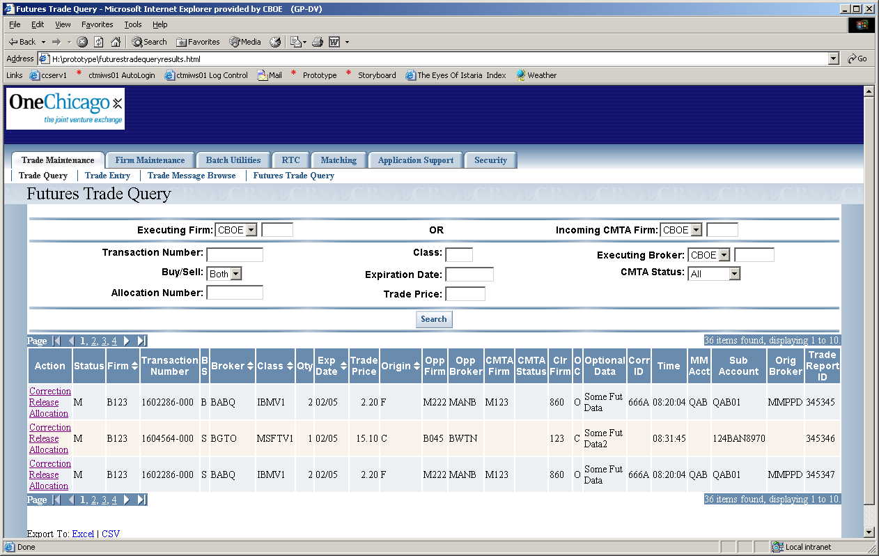
Flow of Events | - User selects “Futures Trade Query” from the menu.  - Futures Trade Query screen appears  - User must select the executing exchange  - User can then select to search using either the executing firm or the incoming CMTA firm.  - Executing Firm  - List of executing firms will be limited by role. Roles will permission to select any firm will be allowed to select any firm. Roles with limited firm selection will be limited to firms they are authorized for.  - Incoming CMTA Firm  - List of firms will be limited by role. Roles will permission to select any firm will be allowed to select any firm. Roles with limited firm selection will be limited to firms they are authorized for.  - User can filter the results of the query by using any of the following fields:  - Transaction Number  - Buy/Sell – limited to “Both”, “Buy” and “Sell”  - Allocation Number  - Class  - Expiration Date  - Trade Price  - Broker Exchange – Limited to “CBOE”, “CME”, “CBOT”  - Broker Exchange will only be used as criteria if the Executing Broker is filled in.  - Executing Broker  - CMTA Status – Limited to “Valid”, “Invalid”, “Error” and “Release”  - The user will press the Search Button to submit the criteria for searching.  - Search criteria will be passed to CTM-R for searching  - Search results will be displayed on the Futures Trade Query screen in a table format  - Standard table paging will be available.  - The user will be able to export the data to Excel or Comma Separated Values. The whole set of data will be exported, not just the page of data being displayed.  - The fields that will show in the table are  - Status  - Executing Firm – Displays Exchange and Firm  - Transaction Number  - Buy/Sell  - Broker – Displays Exchange and Broker  - Class  - Quantity  - Expiration Date  - Trade Price  - Origin  - Opposite Firm – Displays Exchange and Firm  - Opposite Broker – Displays Exchange and Broker  - CMTA Firm – Displays Exchange and Firm  - CMTA Status  - Clearing Firm  - Open/Close  - Optional Data  - Correction ID  - Time of Execution  - Market Maker Account  - Sub Account  - Originating Broker – Displays Exchange and Broker  - Trade Report ID  - Sorting will be available on the following fields  - Executing Firm  - Executing Broker  - Class  - Expiration Date  - Origin  - On each trade the user might have the following actions available  - Correction – Activates Futures Trade Correction Use Case  - Correction Link is available if all the following conditions are met  - For a search done by Executing Firm  - Post Trade Processing Firm Exchange is CBOE  - Post Trade Processing Exchange & Firm equals Exec Exchange & Firm or user is a Super User  - CMTA Status is not “R”.  - For a search done by Incoming Firm  - Post Trade Processing Firm Exchange is CBOE  - Post Trade Processing Exchange & Firm equals CMTA Exchange & Firm or user is a Super User  - Post Trade Processing Exchange is not equal to Executing Firm Exchange  - Release – Activates Futures Trade Release Use Case  - For a search done by Executing Firm  - Post Trade Processing Firm Exchange is CBOE  - Post Trade Processing Exchange & Firm equals Exec Exchange & Firm or user is a Super User  - CMTA Status is “R”.  - Executing Firm Exchange does not equal CMTA Firm Exchange.  - For a search done by Incoming Firm  - Post Trade Processing Firm Exchange is CBOE  - Post Trade Processing Exchange & Firm equals CMTA Exchange & Firm or user is a Super User  - Post Trade Processing Exchange is not equal to Executing Firm Exchange  - Allocation – Activates Futures CMTA Allocation Use Case  - For a search done by Executing Firm  - Post Trade Processing Firm Exchange is CBOE  - Post Trade Processing Exchange & Firm equals Exec Exchange & Firm or user is a Super User  - CMTA Status is not “R”.  - Allocation Number is equal to 000  - Quantity is greater than 1  - CMTA Status is spaces  - For a search done by Incoming Firm  - Post Trade Processing Firm Exchange is CBOE  - Post Trade Processing Exchange & Firm equals CMTA Exchange & Firm or user is a Super User  - Post Trade Processing Exchange is not equal to Executing Firm Exchange  - Allocation Number is equal to 000  - Quantity is greater than 1
Alternative Path | 1.1 At any time the user can click the Search button and execute, or refresh the search..

